DOCKER TASK
Task Description:
Install docker on EC2 and explore the docker commands (docker images, containers, volumes, network)
O/P:
a) Install docker on EC2:
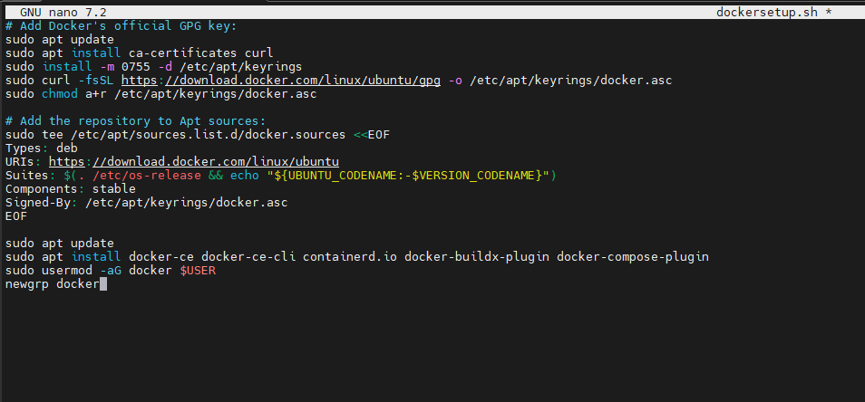
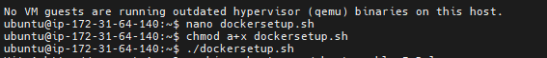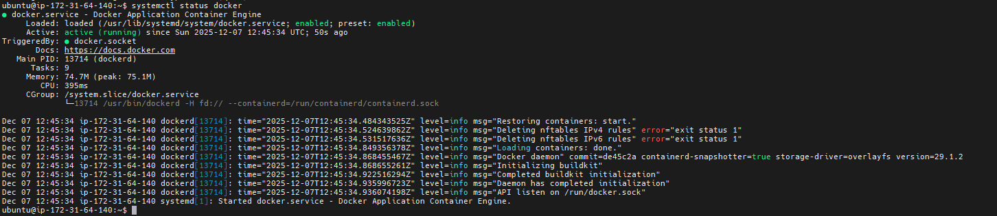
b) Docker Images:
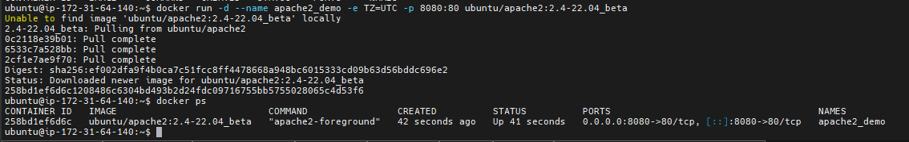
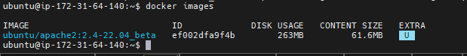
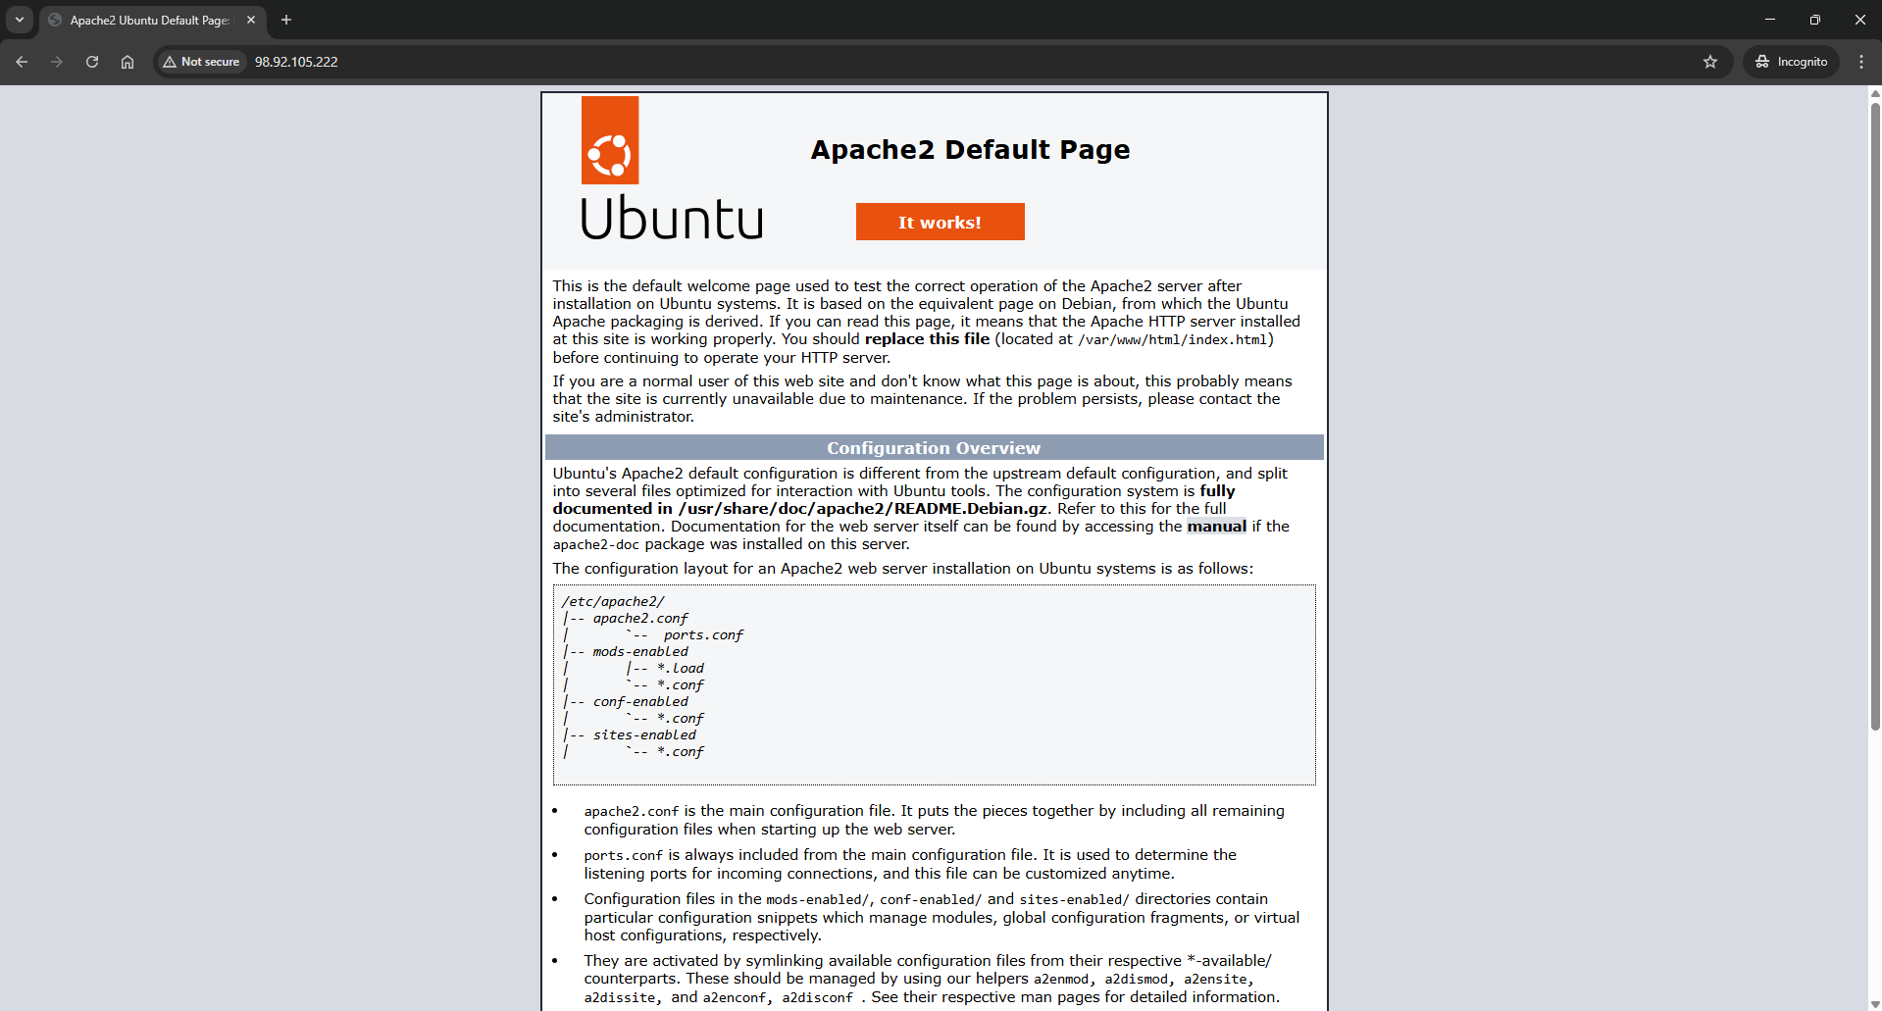
c) Docker Containers:
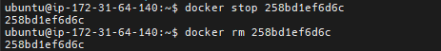
d) Docker Volume:
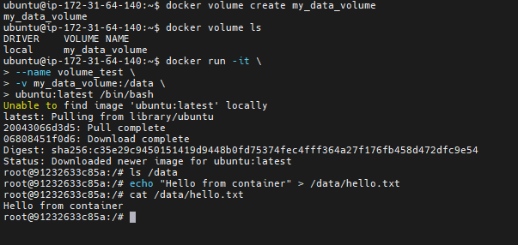
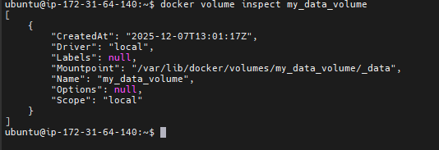
e) Docker Network:
